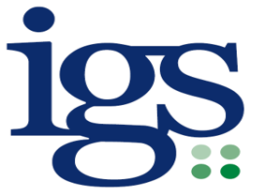

DATA PROTECTION OFFICER SERVICE for SCHOOLS

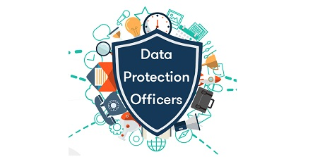

Let us support you by providing simple solutions to complex issues, assuring your compliance with Data Protection legislation

About Us
We have been delivering services since 2017. We developed our traded service to support schools in getting to grips with the change to data protection legislation. We are well placed to provide services and advice as we sat on national implementation groups for the new legislation including addressing other Public Bodies at the ICO Data Protection Practitioners Conference to assist them in preparing for GDPR as well as Education and Local Government specific conferences around the country.

The IGS Team is a group of Information Governance Professionals dedicated to supporting others in their compliance with information legislation. Our Officers are experienced and certified Data Protection and GDPR Practitioners and have a wealth of experience and qualifications in Freedom of Information, Risk Management, Audit and Security & Privacy Professional certification.
Lauri Almond
Team Manager

We use our wealth of experience and qualifications to act as Data Protection Officer for schools. Our compliance audit helps to benchmark your current compliance level and provides an action plan to reach a satisfactory level. We can also provide you with a GDPR framework of documents which provide all the documentation you will need to evidence your compliance with the law.

Kellene Green
Senior IG Officer
Our training is provided in bespoke packages, tailored to meet the needs of each client, ensuring that you get the training you need on the data protection topics most relevant to you. Our GDPR Basics for Virtual Training Schools module is an easy way to evidence that your staff have been appropriately trained to understand their responsibilities.
Our incredibly high retention rate for our DPO service customers is evidence of the high-quality service we provide. Excellent customer service is our priority. Let us take away uncertainty by providing you with all the support you need to meet your data protection obligations.

Data Protection Officer (DPO) Service

This award-winning service is designed to provide you with the required statutory role, and includes:

- Fulfilling the DPO role in monitoring compliance with GDPR, acting as a point of contact for both the Information Commissioners Office (ICO) and for Data Subjects
- Unlimited advice and guidance from our helpdesk
- A Compliance Framework which includes all documentation required to evidence compliance with data protection law
- An annual audit with action plan for any required improvement
- An annual report to the Board of Governors/Trustees
- Statutory Request Completion (FOI, EIR, SAR)
- ICO Complaint handling
- Access to free school focussed GDPR Virtual Training for staff

This is what our schools say about our DPO service:

"The audit was very useful. Everything was explained with patience and knowledge. The atmosphere of the meeting was relaxed, purposeful and informative." Head Teacher, South Essex Secondary School
“I initially found GDPR rather overwhelming as I really didn't understand it. The team at IGS have been amazing with their telephone support and online resources. I am proud to say that we now meet the required standards.” Business Manager, Essex Primary School

Very friendly helpful, supportive team. Thank you.

Thank you for all that you are doing. We are very glad we have you in our corner.

Always very helpful if I have cause to telephone - I feel able to ask anything, however 'silly' it may seem, and it will be taken seriously and a full explanation of the reason behind the answer, so it makes more sense.

Lite Support Service
This is a service which is suited to those who wish to assign their own DPO, but who need advice and guidance to support them, it includes:
- 8 hours of advice and guidance from our helpdesk
- Access to free school focussed GDPR Virtual Training for staff

Pay as You Go Services

A range of services which can be accessed on an ad hoc basis when required, which include:
        - Advice and guidance from our helpdesk
- Statutory Request fulfilment
- ICO Complaint fulfilment
- Data Compliance Audit
- Consultancy
- Bespoke Training sessions
- Compliance Framework
- Access to Virtual Training

Our approach to DPO as a service

We recognise that schools do not necessarily have the in-house expertise to take on this statutory role. We also recognise that schools are highly likely to have conflicts of interests where the role is assigned internally. As a Local Authority with vast experience of information governance we can provide a cost-effective service, working closely with schools to ensure they feel supported, building a trusting relationship between the school and the officer assigned to their school.
We support schools by providing a service inclusive of:
  - An annual audit with an action plan for any required improvements
  - An annual report for the Governing Body/Board of Trustees
  - A helpdesk to handle unlimited email or telephone queries
  - A Compliance Framework, providing the tools needed to evidence your compliance
  - Access to school focussed GDPR Virtual Training for all your staff
  - A monthly Newsletter sharing updates, best practice and Q&As
  - Statutory Requests and ICO Complaint completion
IGS were delighted to receive the Innovation of the Year Award from the Information and Records Management Society in May 2018 in recognition of the Schools Data Protection Officer Service provided to schools. The award recognises the comprehensive and innovative framework which supports schools’ compliance with the legislation removing some of the burden associated with compliance.
Our comprehensive Compliance Framework offers a wealth of prepopulated documents to support your compliance, reducing workload for the school and supporting understanding. The framework is regularly reviewed to ensure it takes account of any changing regulatory views or case law and to identify ways to simplify documentation. There are no hidden costs with our service, advice and guidance is unlimited as this is a key component of the DPO role in supporting the school’s compliance.

Why choose IGS?

We take pride in our service and the excellent feedback we receive from customers. We strive to deliver a professional service with a human touch. We understand the time and financial pressures schools face, we face them too as a Public Body, so it is vital to us that we provide value for money to our customers. No hidden costs help you to budget confidently for this service.
We have conducted competitor analysis and can honestly say that our service is the most comprehensive package available offering great value for money. Whilst some providers choose to focus on technical solutions, we understand that it is human understanding that underpins compliance and choose to invest in providing the documentation and personnel to support your needs.
We are the only DPO Service provider who offer to complete Subject Access Requests (SARs) on behalf of schools as part of our core service offering as this can be a complex and time-consuming task. We are also the only providers who offer a Data Protection Impact Assessment (DPIA) Library of systems commonly used by schools, saving the school time and effort in conducting their own assessments.
We have contacted the helpdesk on numerous occasions throughout the year and the support provided has always been excellent. The conference earlier this year was also very helpful.
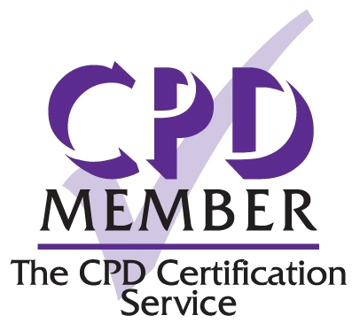
Business Director of a MAT.

We regularly provide half day sessions on GDPR awareness to a variety of organisations; we also provide shorter sessions aimed at teaching staff to highlight how GDPR affects them, or bespoke training sessions tailored to our client’s specific needs.
Our training, both Virtual Training and face to face, is CPD accredited, so you can be assured that the training you receive from us meets the highest standard and enables your staff to earn CPD points to evidence professional development.
When selecting IGS as your provider you can be sure that you will receive a friendly, supportive service tailored to meet your needs. Contact us today and let us support and share your compliance journey.
Information Governance Support (IGS)

IGS Service Offer – pricing 2020/21
Service | Details
Data Protection Officer (DPO) Service | DPO Role | Advice and Guidance | GDPR Basics Virtual Training | Annual Audit | Statutory request completion |  | ICO Complaint Handling
 | ✓ | Unlimited | ✓ | ✓ | ✓ |  | ✓
Schools, MATs, Consortia and Formal Schools Partnerships | 1 - 4 schools = £1500 per school  5 - 10 schools = £1300 per school  10+ schools = £1100 per school |  |  | Please note: Annual audits will be conducted virtually.  Advice & guidance is provided by email or telephone
Lite Support Service  £850 per school | DPO Role | Advice and Guidance | GDPR Basics Virtual Training | Annual Audit | Statutory request completion |  | ICO Complaint Handling
 | ✗ | Maximum 8 hours | ✓ | ✗ | ✗ |  | ✗
Pay as You Go Services
Advice and Guidance  (per hour) | Telephone and email advice on information law compliance, information governance best practice including support with statutory requests. |  |  |  |  | £100
Statutory Request  Fulfilment (per hour) | Completion of Freedom of Information, Environmental Information Regulation and Subject Access Requests. |  |  |  |  | £150
ICO Complaint Fulfilment (per hour) | Preparation of responses to ICO complaints. |  |  |  |  | £300
Data Compliance Audit (One day) | Onsite Data Compliance Audit gathering findings from pre-audit questionnaire, employee interviews and presenting recommendations for a compliance action plan (includes compliance templates training). |  |  |  |  | £1000
Consultancy  (per hour) | Targeted support on information governance areas of specific concern  (travel to sites will be chargeable time). |  |  |  |  | £100
Virtual Training  (per course) | A range of CPD Accredited virtual training courses, delivered by a qualified practitioner on a range of data protection topics. |  |  |  |  | £30 - £65 per module
Bespoke Training  (½ Day) | CPD Accredited training courses relating to data protection subject matter built to meet your specific needs. |  |  |  |  | £500
IGS Framework (Compliance Evidence Templates) | Document templates to be used as evidence of compliance for regulators and auditors, containing over 60 documents, most documents are pre-populated to help assure your compliance and reduce your workload.  Free with an Audit. For schools: £200 per school if buying a training course |  |  |  |  | £400

Please contact IGS@essex.gov.uk or call 03330 322970 if you wish to access services.
Prices do not include VAT (charged where applicable).
The IGS Framework (Compliance Evidence Templates) is under copyright and is a licenced product.

